**Arrays:**

* Arrays are fixed in size.
* Homogeneous
* No underlying data structure—No methods available to search and sort. Manually we should write.

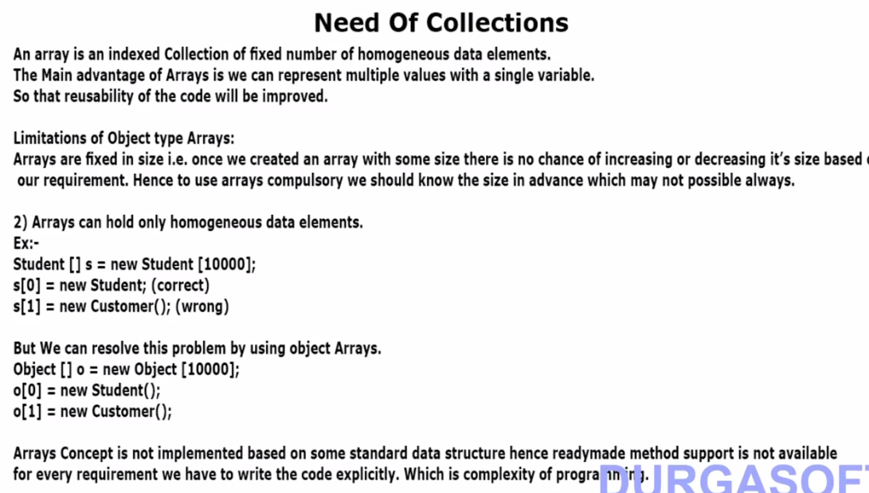



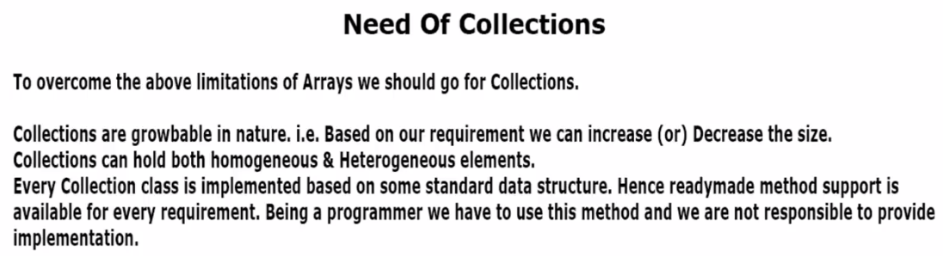

Assuming 10 elements are there in array list and we want to insert the 11th element.

**Initially:**

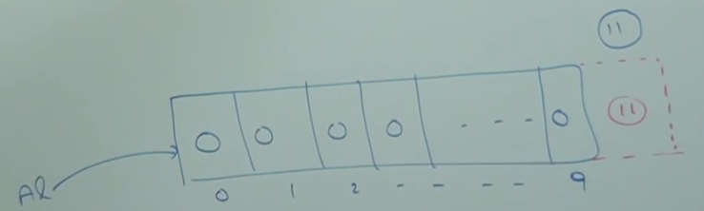

Internally a bigger array list will be created. All 10 elements will be copied from old AL to newly created AL. The reference will be pointed to new AL and old AL will be eligible for garbage collections.

**Finally:**

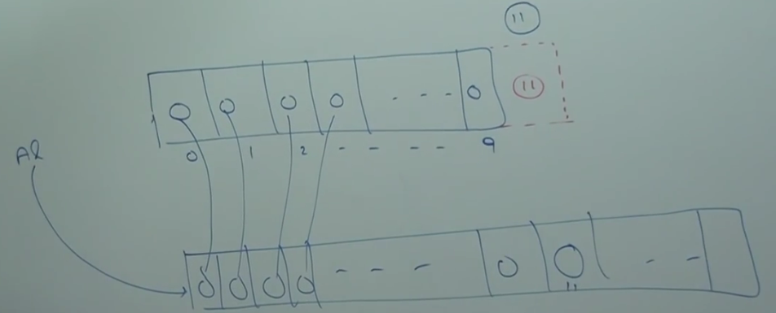

**Difference between Arrays and Collections**

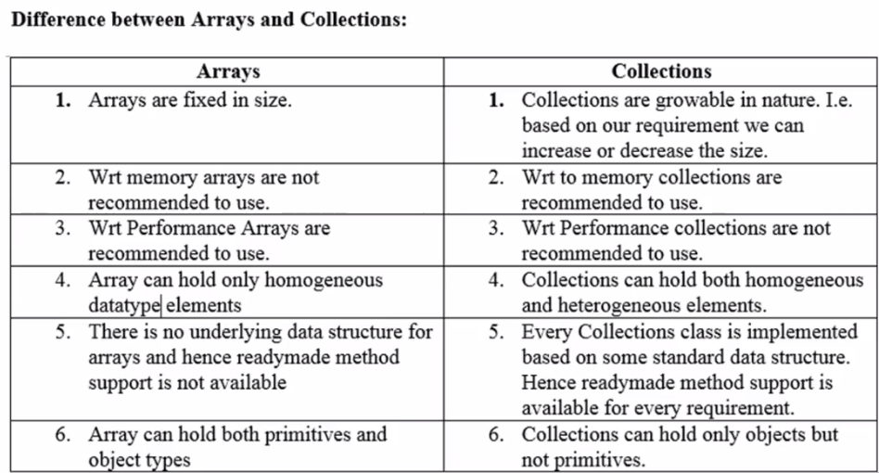

**What is Collection?**

If we want to represent a group of individual objects as a single entity then we should go for Collection.

**What is Collection Framework?**

It defines the several classed and interfaces which can be used to group objects as a single entity.



**9 Key Interface of Collection Framework:**

1. **Collection**
2. **List**
3. **Set**
4. **Sorted Set**
5. **Navigable Set**
6. **Queue**
7. **Map**
8. **SortedMap**
9. **NavigationMap**

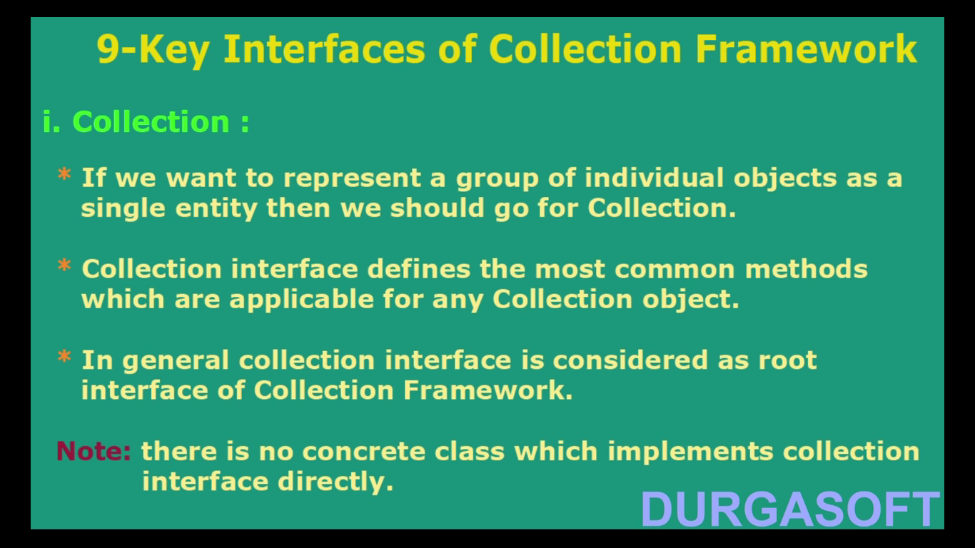

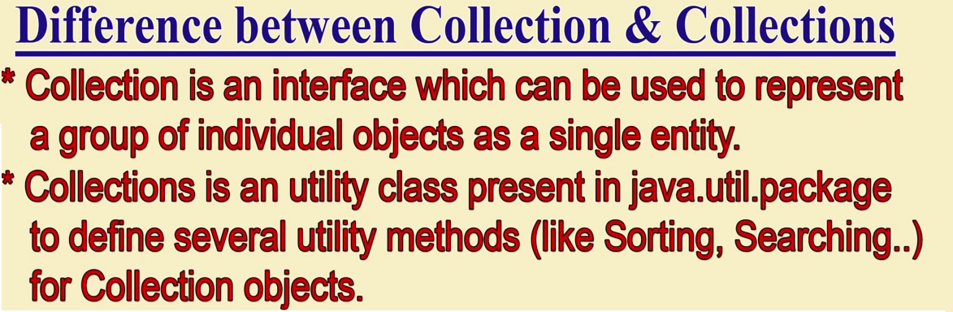

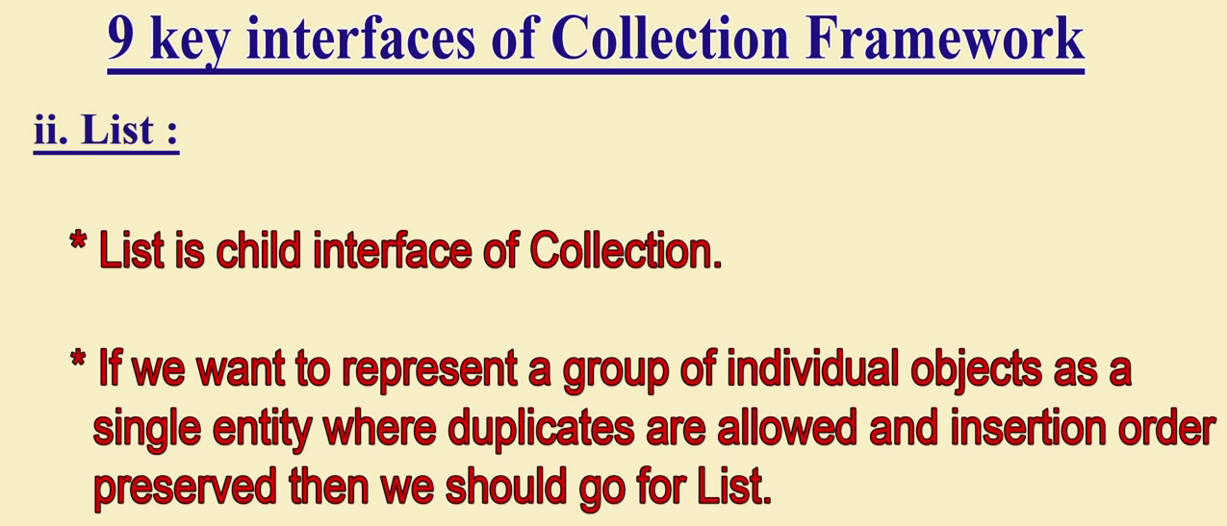

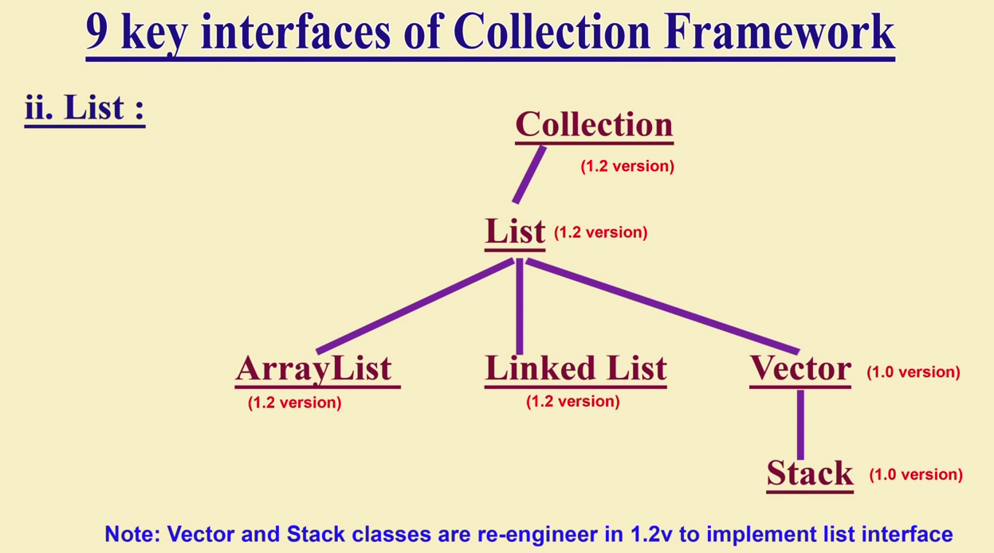

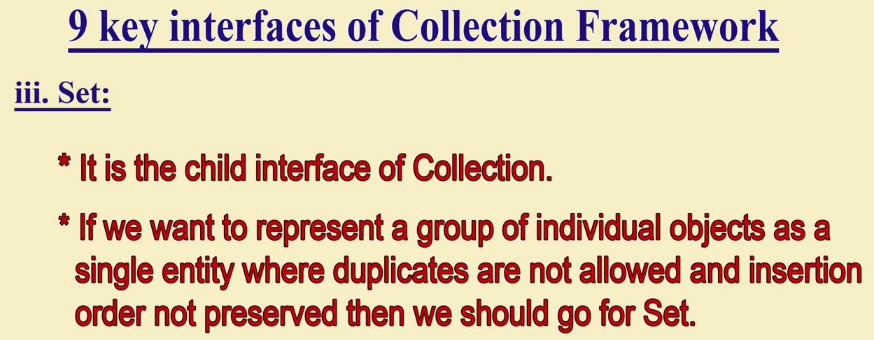

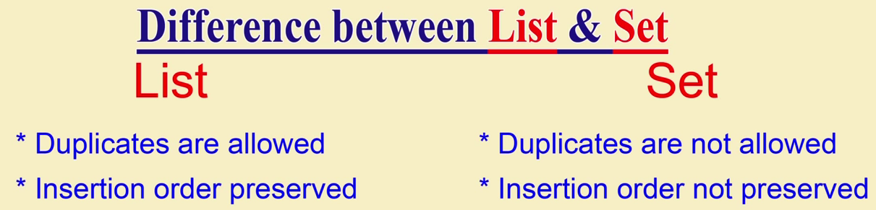

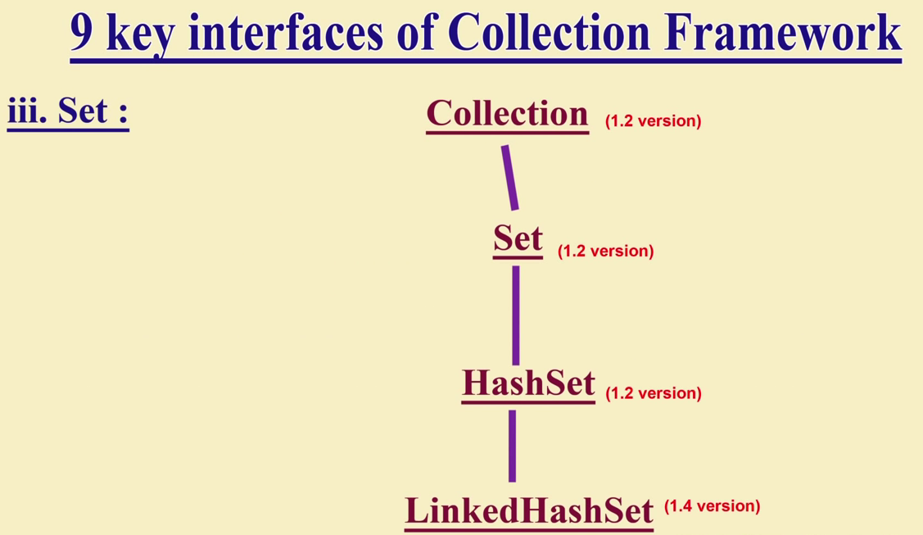

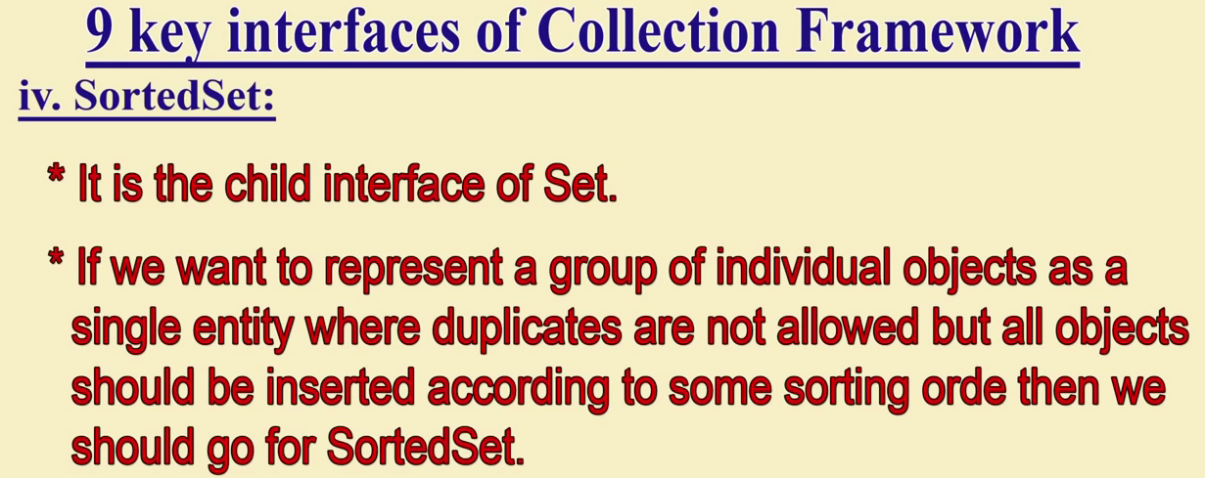

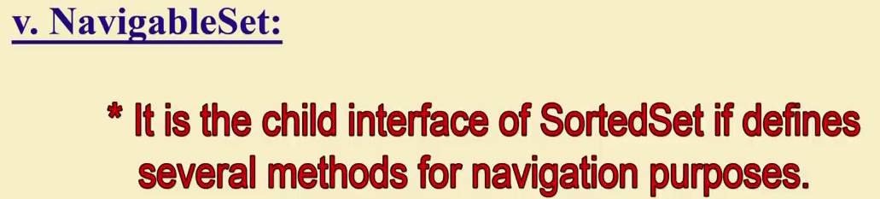

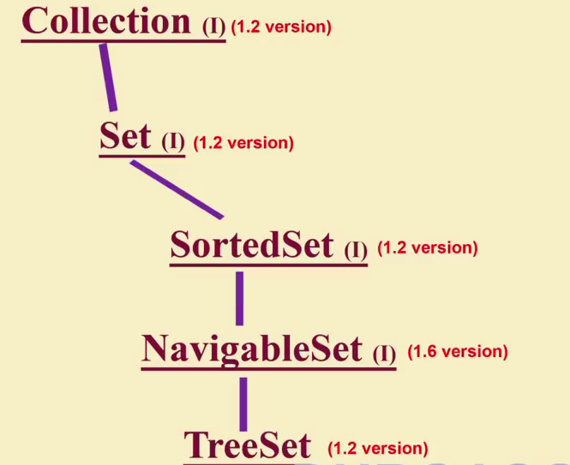

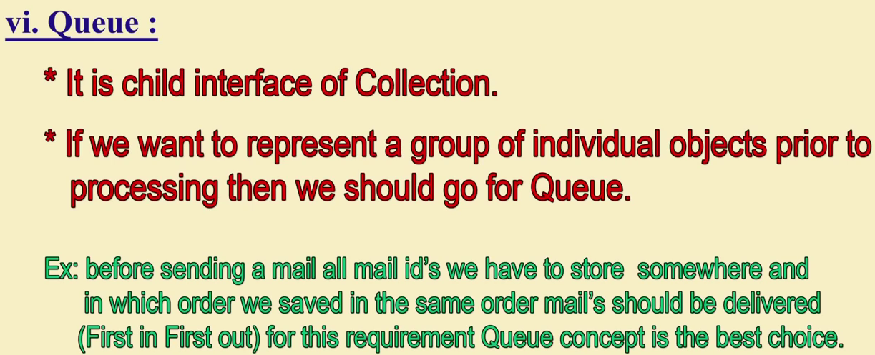

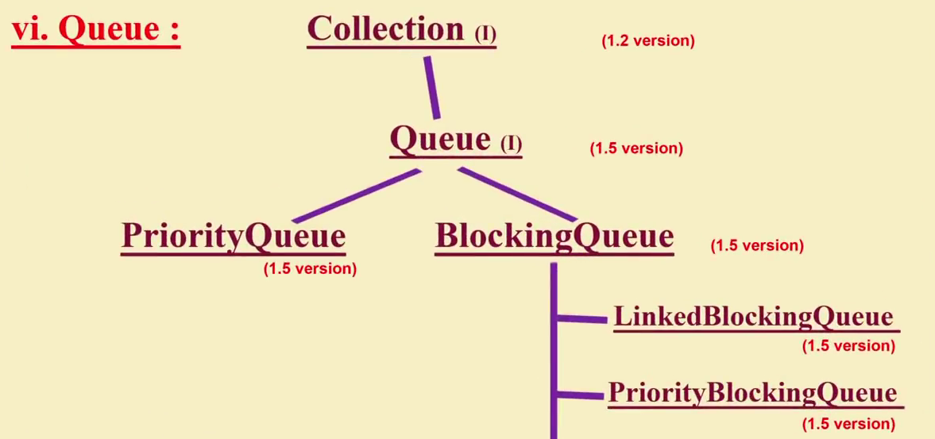

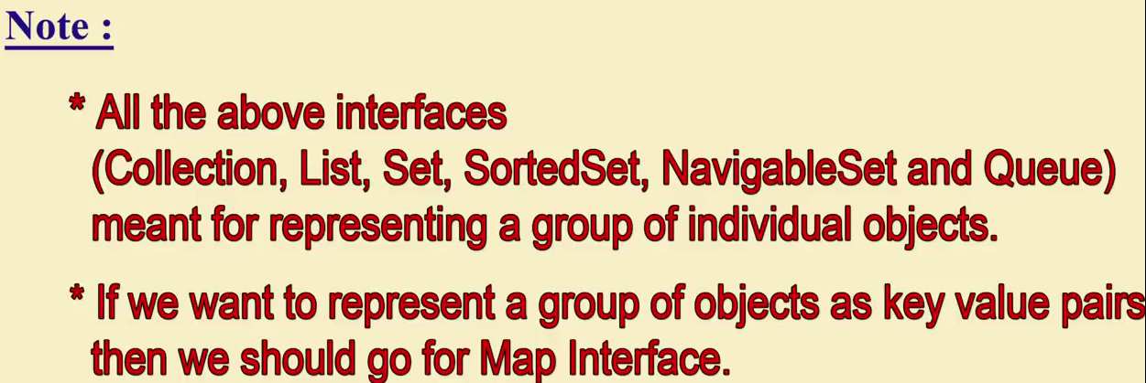

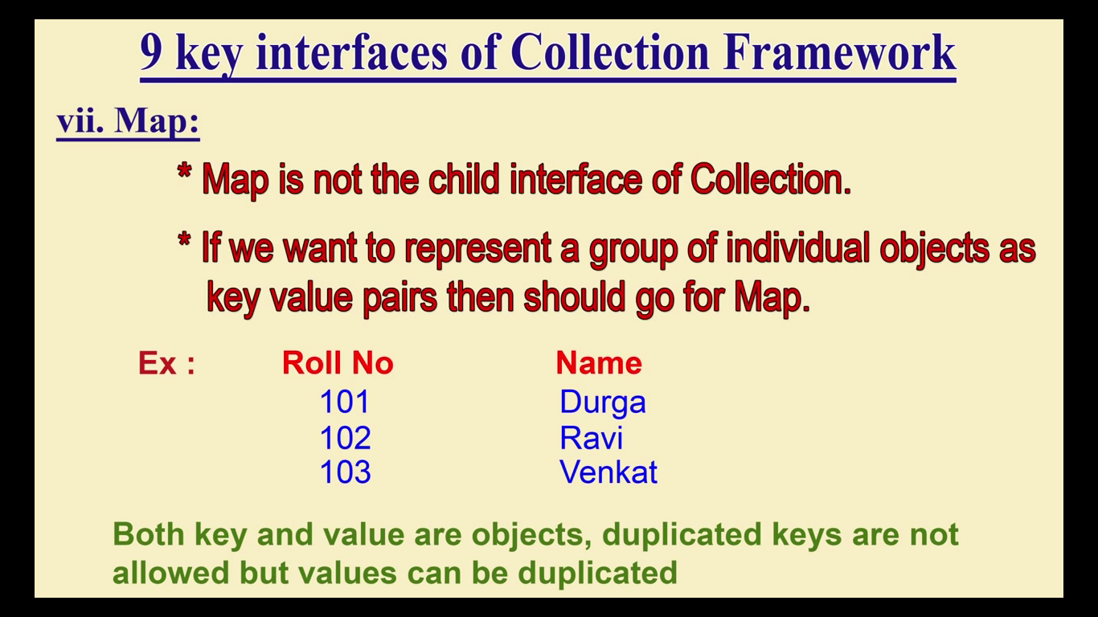

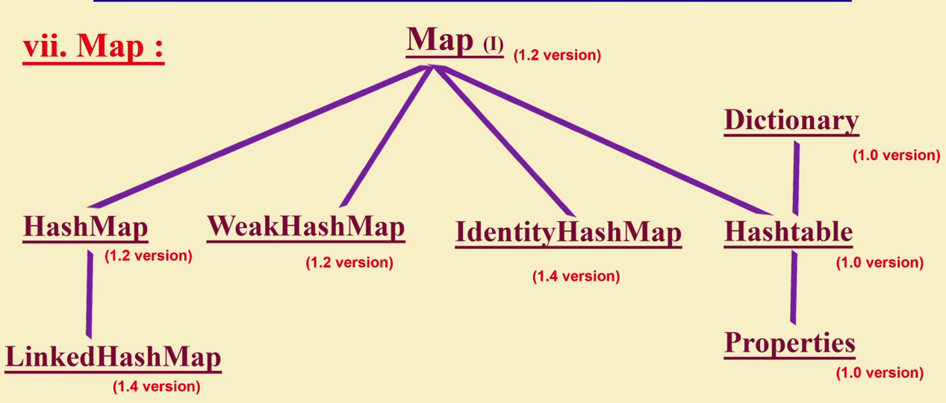

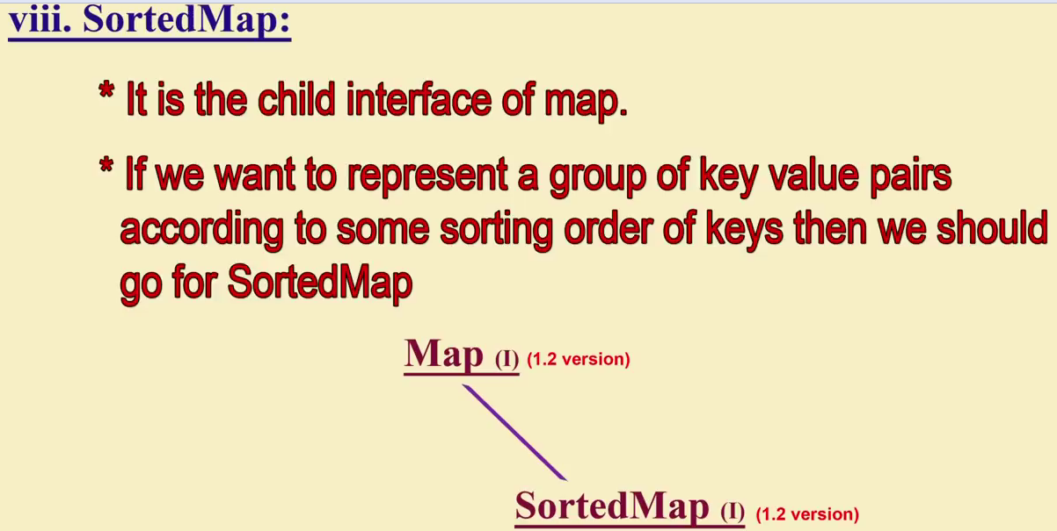

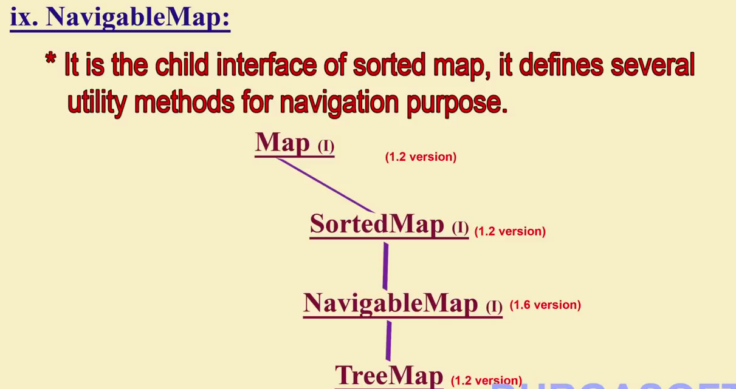

**Collections Framework Overview:**

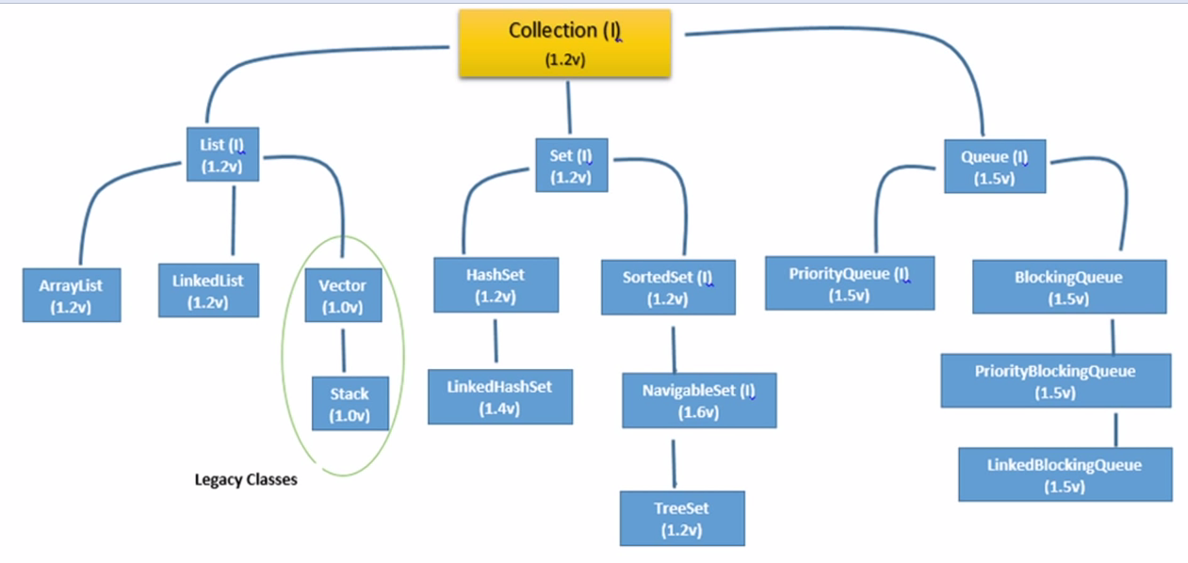

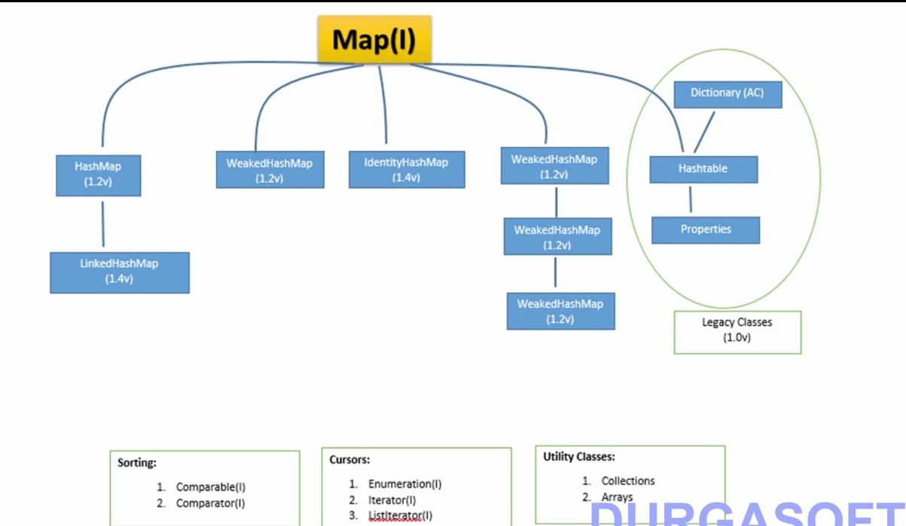

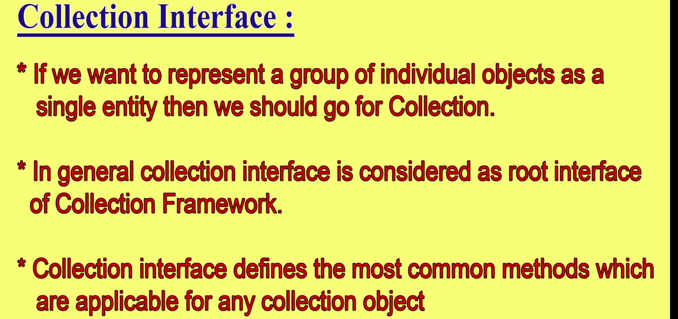

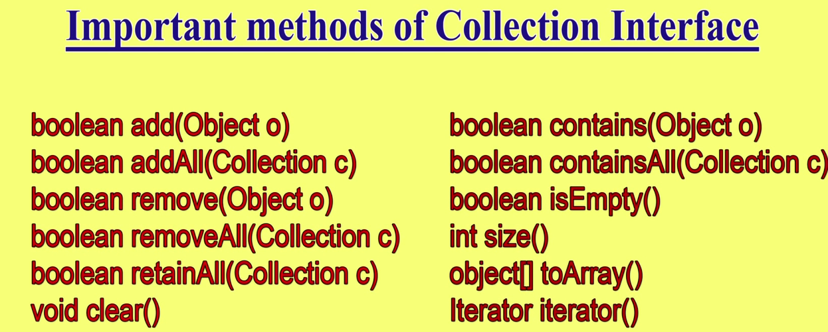

**Note*: Collection Interface doesn’t contain any method to retrieve objects there is no concrete class which implements collection interface directly.**

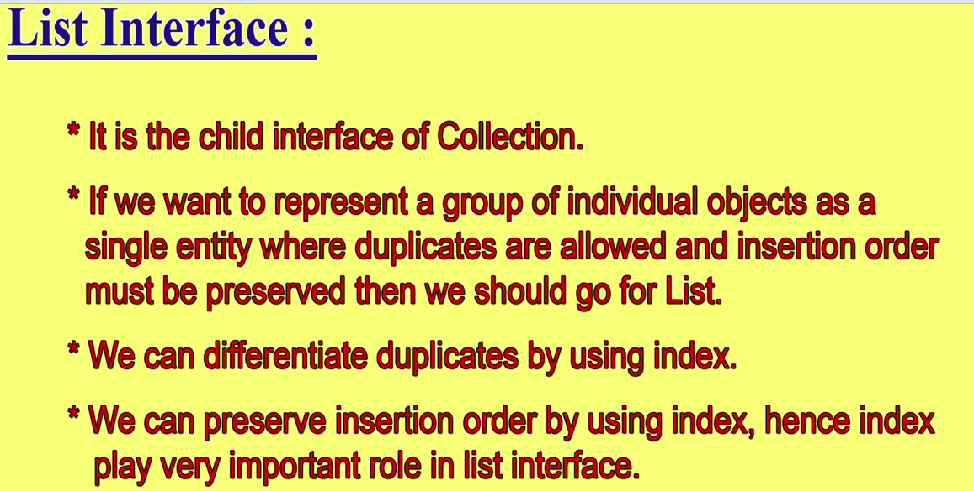

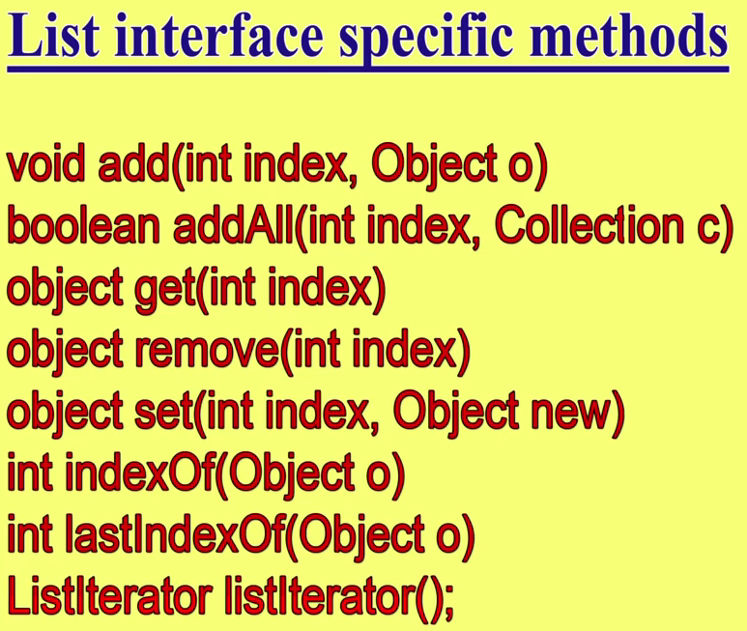

**ArrayList:**

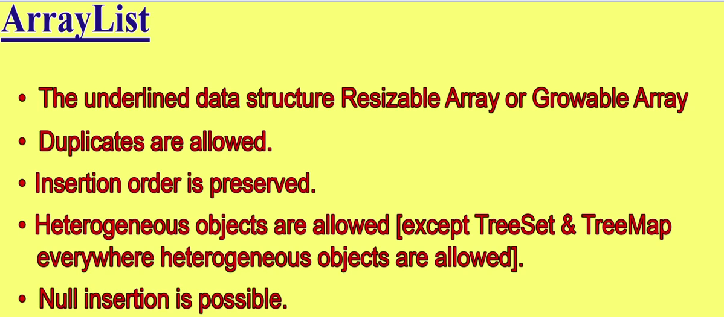

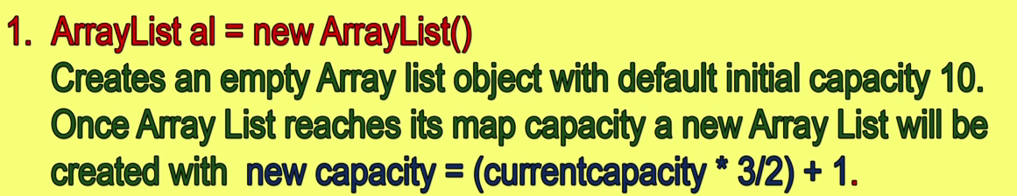

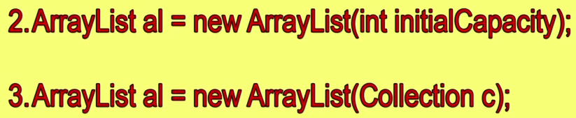



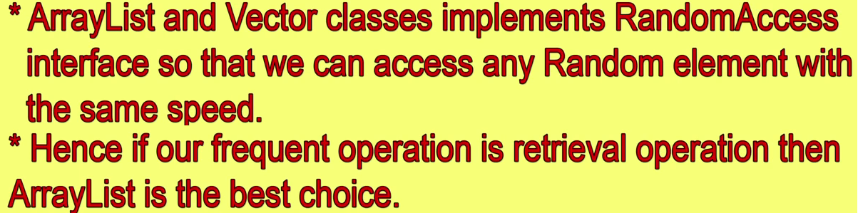

**Random Access Interface:**

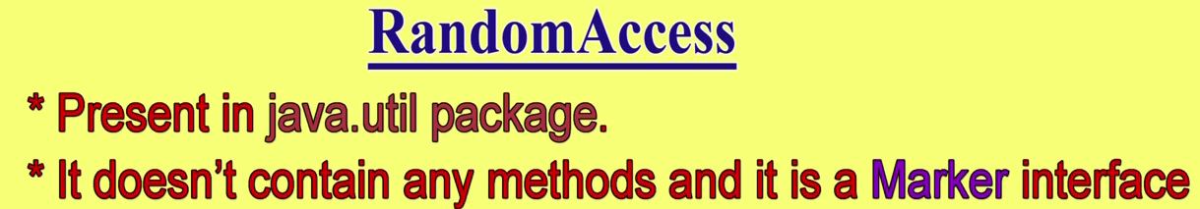

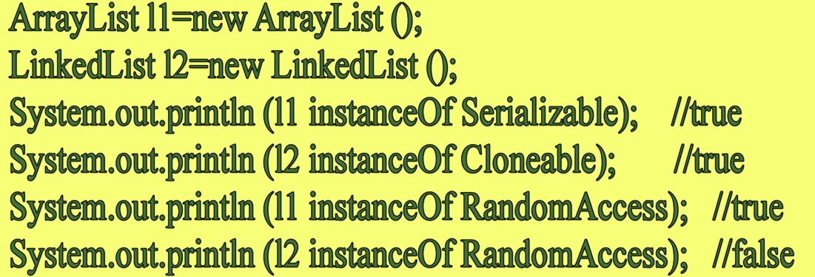

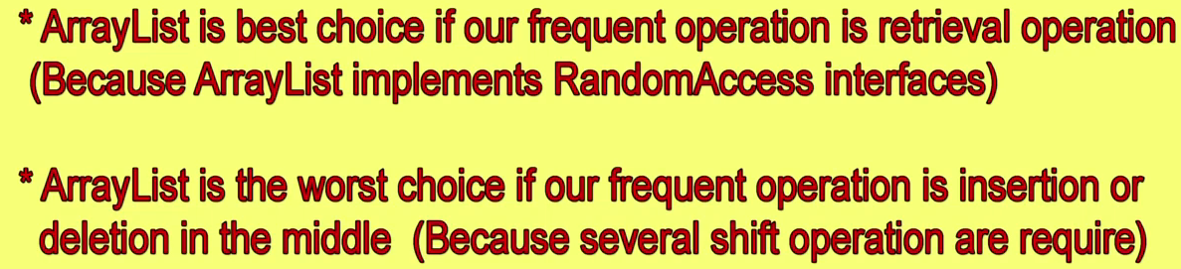

**Difference between ArrayList and vector:**

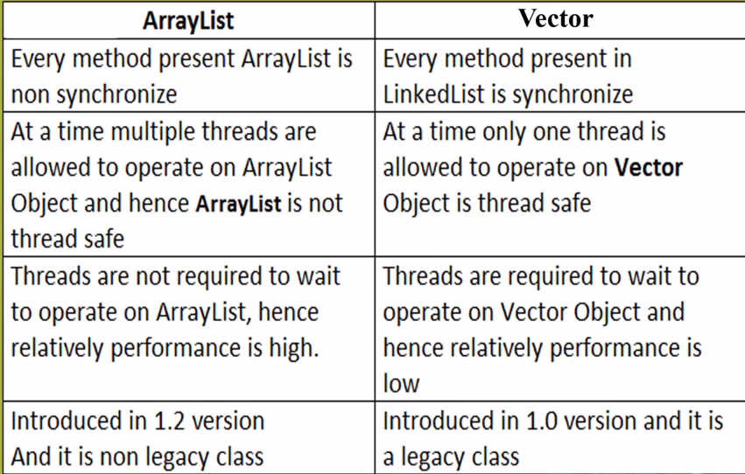

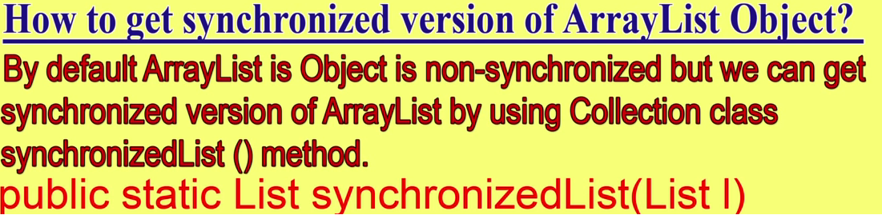

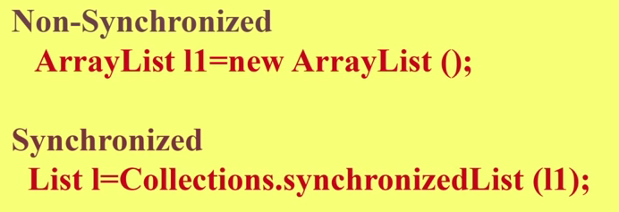

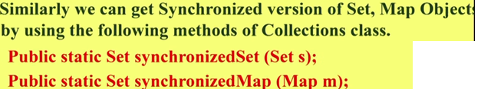

**Linked List:**

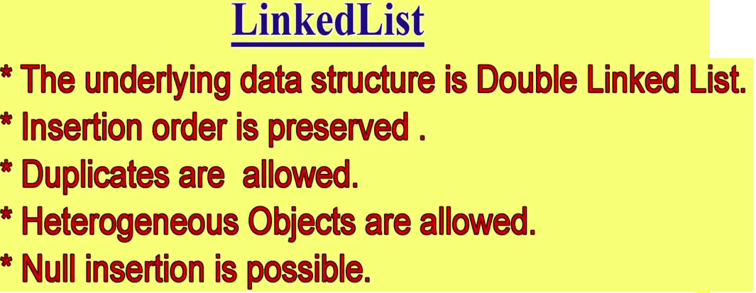

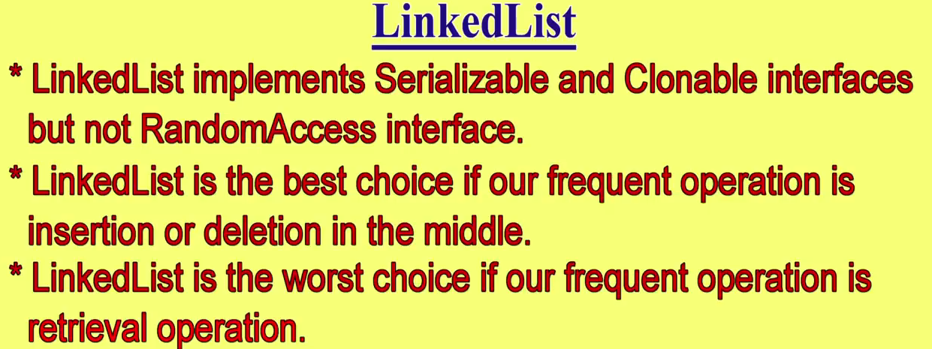

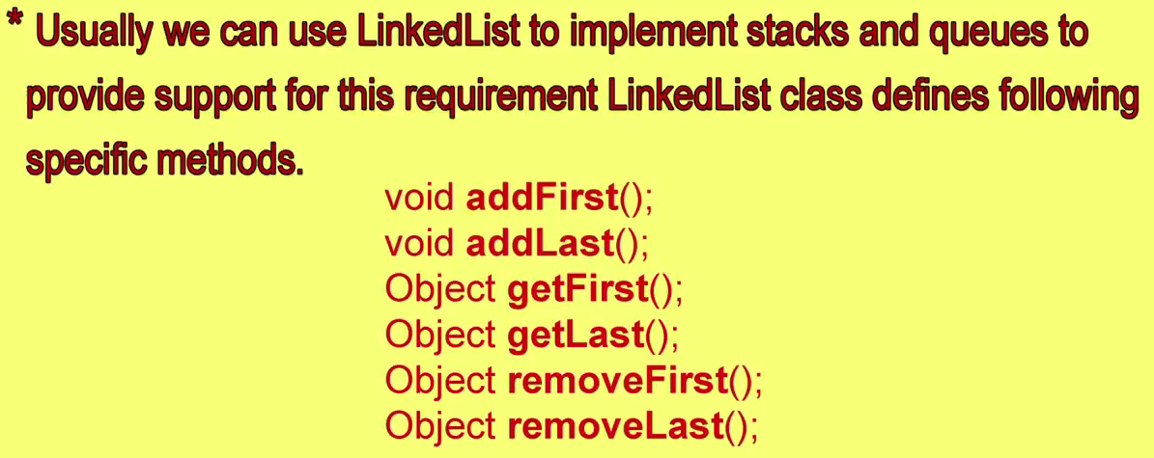

**Linked List Constructor:**

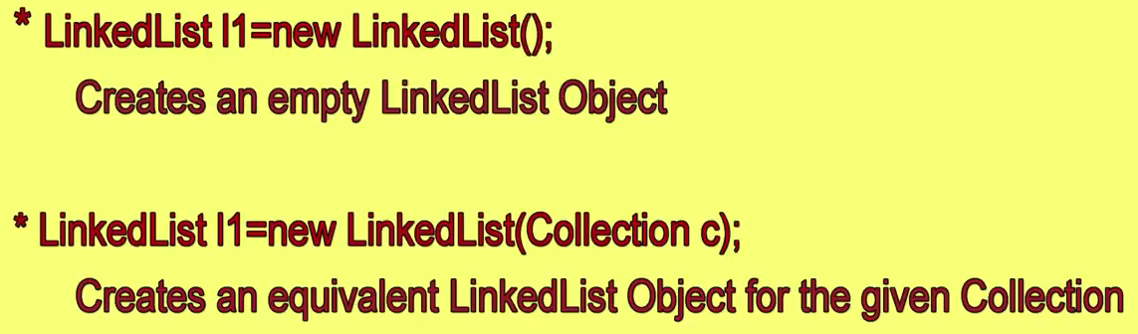

**Difference between ArrayList and LinkedList**

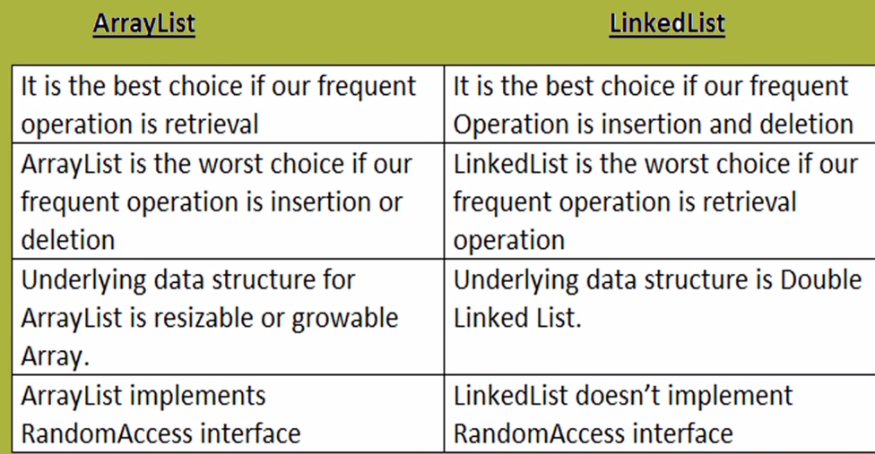

**Vector:**

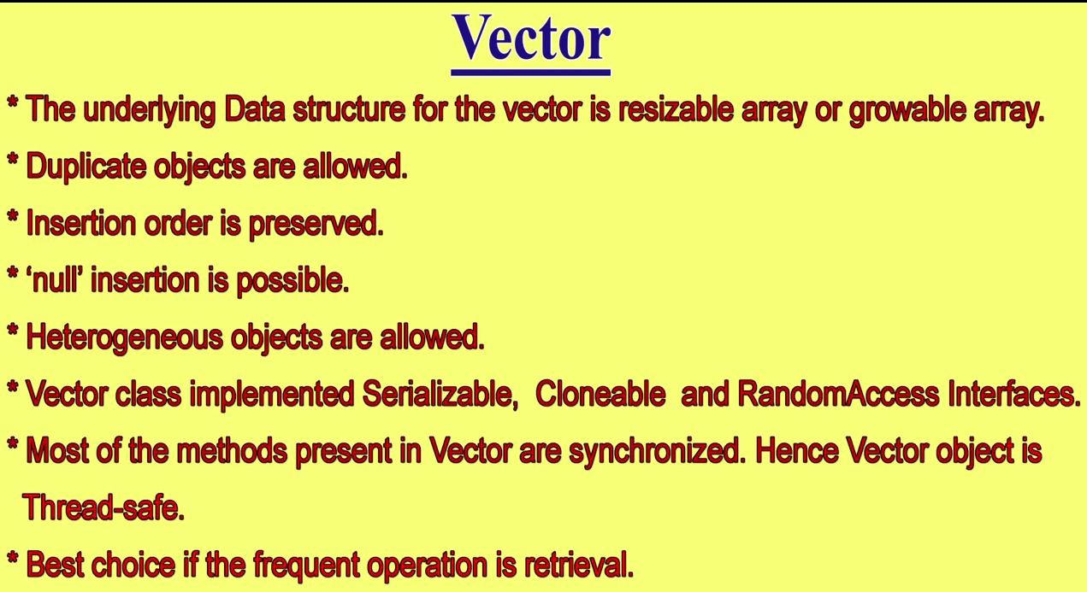

**To Add Elements:**

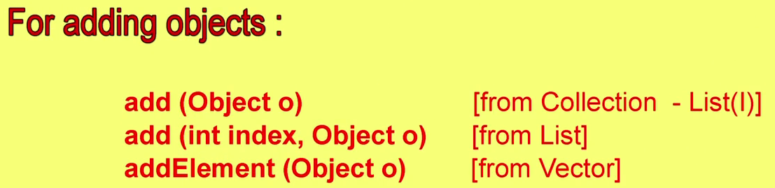

**To Remove Elements:**

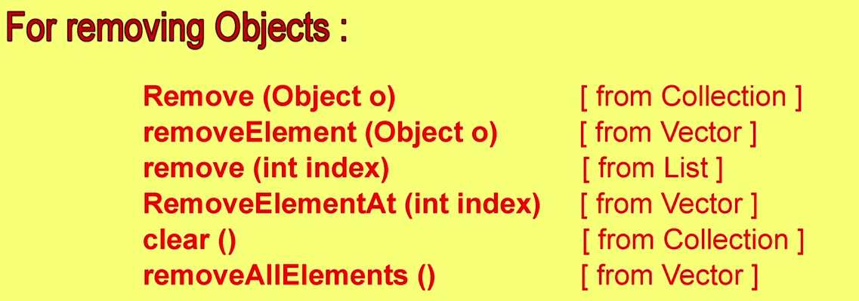

**To Access Elements:**

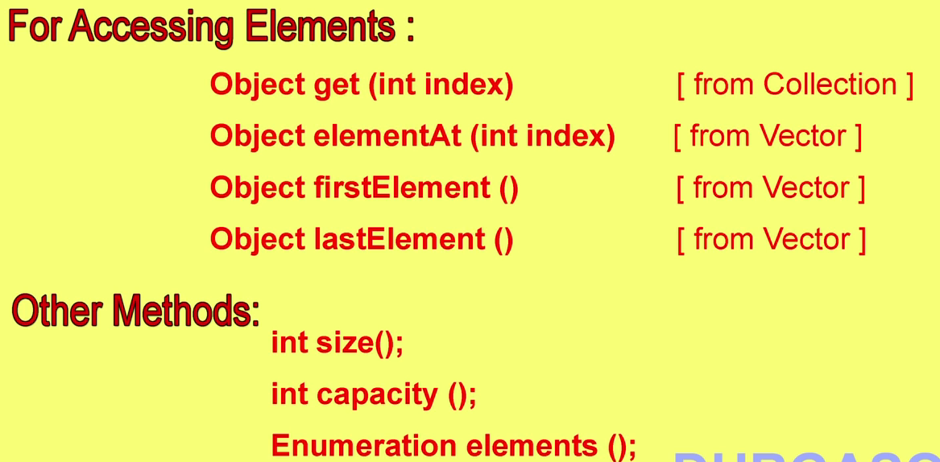

**Constructor of Vector Class:**

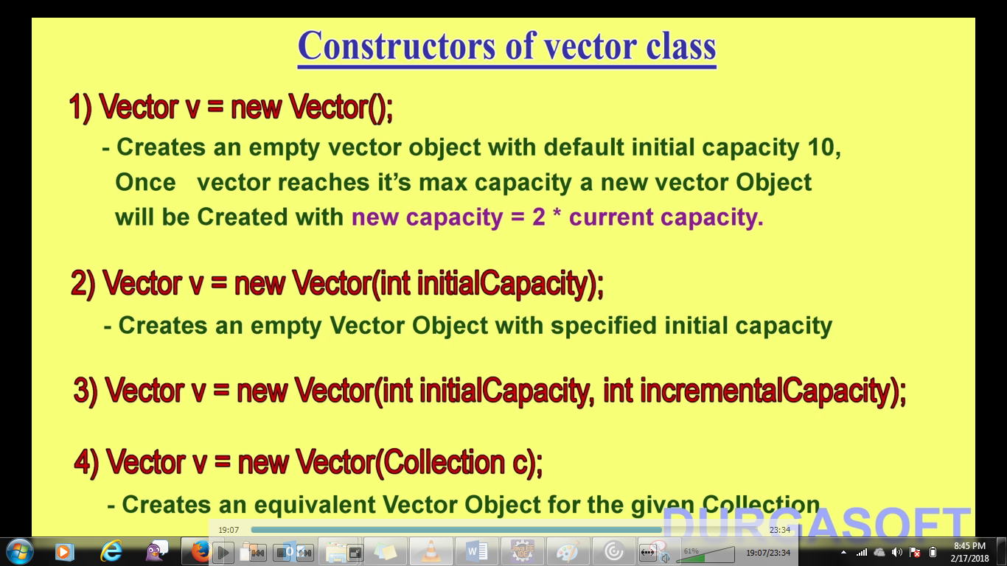

**Stack: Constructor: Stack s = new Stack();**



